|  |  |  |
| --- | --- | --- |
| In | [1]: | **import** pandas **as** pd  **import** seaborn **as** sns |
|  |  |  |
| In | [2]: | data**=**pd.read_csv(r"D:\College\TE\SEM-2\Practical\DSBDA\10\Iris.csv") |
|  |  |  |
| In | [3]: | data.head() |

|  |  |  |  |  |  |  |  |
| --- | --- | --- | --- | --- | --- | --- | --- |
| Out[3]: |  | | | | | | |
|  |  | **Id** | **SepalLengthCm** | **SepalWidthCm** | **PetalLengthCm** | **PetalWidthCm** | **Species** |
|  | 0 | 1 | 5.1 | 3.5 | 1.4 | 0.2 | Iris-setosa |
|  | 1 | 2 | 4.9 | 3.0 | 1.4 | 0.2 | Iris-setosa |
|  | 2 | 3 | 4.7 | 3.2 | 1.3 | 0.2 | Iris-setosa |
|  | 3 | 4 | 4.6 | 3.1 | 1.5 | 0.2 | Iris-setosa |
|  | 4 | 5 | 5.0 | 3.6 | 1.4 | 0.2 | Iris-setosa |

|  |  |  |  |  |  |
| --- | --- | --- | --- | --- | --- |
| In [4]: | data.describe() |  | | | |
| Out[4]: | **Id** | **SepalLengthCm** | **SepalWidthCm** | **PetalLengthCm** | **PetalWidthCm** |
|  | count 150.000000 | 150.000000 | 150.000000 | 150.000000 | 150.000000 |
|  | mean 75.500000 | 5.843333 | 3.054000 | 3.758667 | 1.198667 |
|  | std 43.445368 | 0.828066 | 0.433594 | 1.764420 | 0.763161 |
|  | min 1.000000 | 4.300000 | 2.000000 | 1.000000 | 0.100000 |
|  | 25% 38.250000 | 5.100000 | 2.800000 | 1.600000 | 0.300000 |
|  | 50% 75.500000 | 5.800000 | 3.000000 | 4.350000 | 1.300000 |
|  | 75% 112.750000 | 6.400000 | 3.300000 | 5.100000 | 1.800000 |
|  | max 150.000000 | 7.900000 | 4.400000 | 6.900000 | 2.500000 |

In [5]:

data.info()

<class 'pandas.core.frame.DataFrame'> RangeIndex: 150 entries, 0 to 149

Data columns (total 6 columns):

Id 150 non-null int64

SepalLengthCm 150 non-null float64 SepalWidthCm 150 non-null float64 PetalLengthCm 150 non-null float64 PetalWidthCm 150 non-null float64 Species 150 non-null object

dtypes: float64(4), int64(1), object(1) memory usage: 7.2+ KB

Out[6]: <matplotlib.axes._subplots.AxesSubplot at 0x2274e737808>

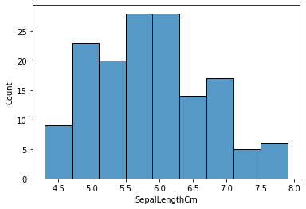

In [7]:

sns.histplot(data**=**data, x**=**"PetalLengthCm")

Out[7]: <matplotlib.axes._subplots.AxesSubplot at 0x2274eab8888>

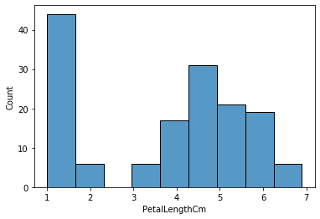

Out[8]: <matplotlib.axes._subplots.AxesSubplot at 0x2274fb0c148>

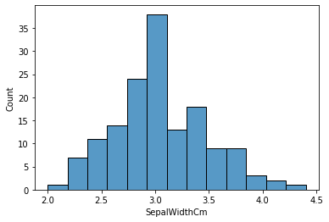

In [9]:

sns.histplot(data**=**data, x**=**"PetalWidthCm")

Out[9]: <matplotlib.axes._subplots.AxesSubplot at 0x2274fbb9088>

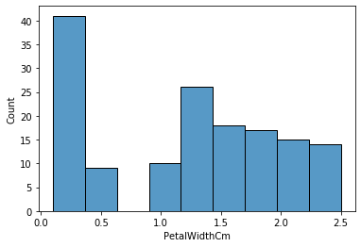

Out[10]: <matplotlib.axes._subplots.AxesSubplot at 0x2274fc47d88>

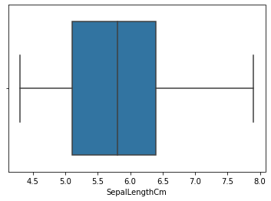

In [11]:

sns.boxplot(x**=**"PetalLengthCm", data**=**data)

Out[11]: <matplotlib.axes._subplots.AxesSubplot at 0x2274fc977c8>

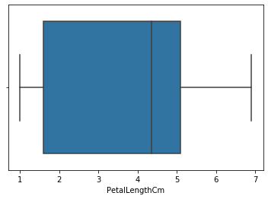

Out[12]: <matplotlib.axes._subplots.AxesSubplot at 0x2274fd2a3c8>

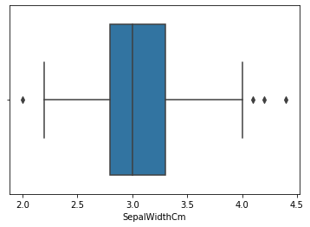

In [13]:

sns.boxplot(x**=**"PetalWidthCm", data**=**data)

Out[13]: <matplotlib.axes._subplots.AxesSubplot at 0x2274fc58548>

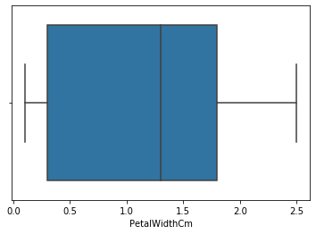

Out[14]: <matplotlib.axes._subplots.AxesSubplot at 0x2274fdd4648>

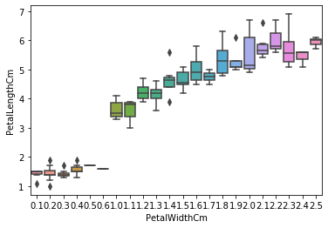

In [15]:

sns.boxplot(x**=**"SepalWidthCm", y**=**"SepalLengthCm", data**=**data)

Out[15]: <matplotlib.axes._subplots.AxesSubplot at 0x2275004c188>

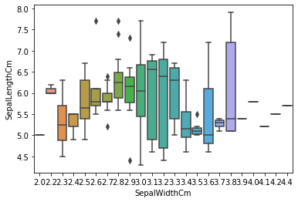

In [ ]: